Andre Hardy – Project 3-1

VirusTotal is a free online service that analyzes files and urls to identify potential malware. VirusTotal combines 70 antivirus scanners and url/domain blacklisting services along with other tools to identify malware. A wide range of files can be submitted to VirusTotal for examination, such as user data files and documents, executable programs, pdFs, and images. one of the uses of VirusTotal is to provide a “second opinion” on a file or url that may have been flagged as suspicious by other scanning software. In this project, you use VirusTotal to scan a file and a url.
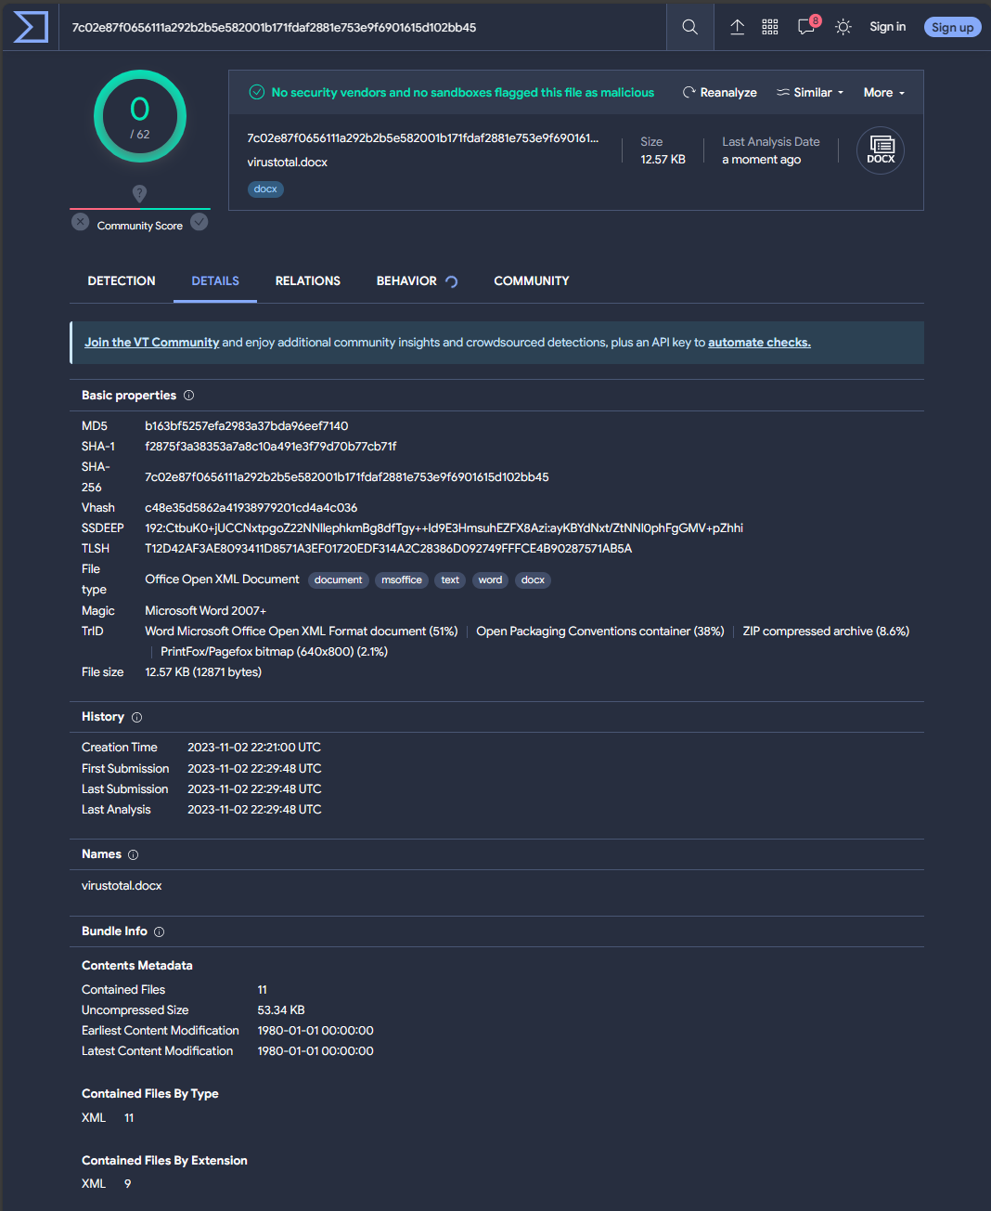
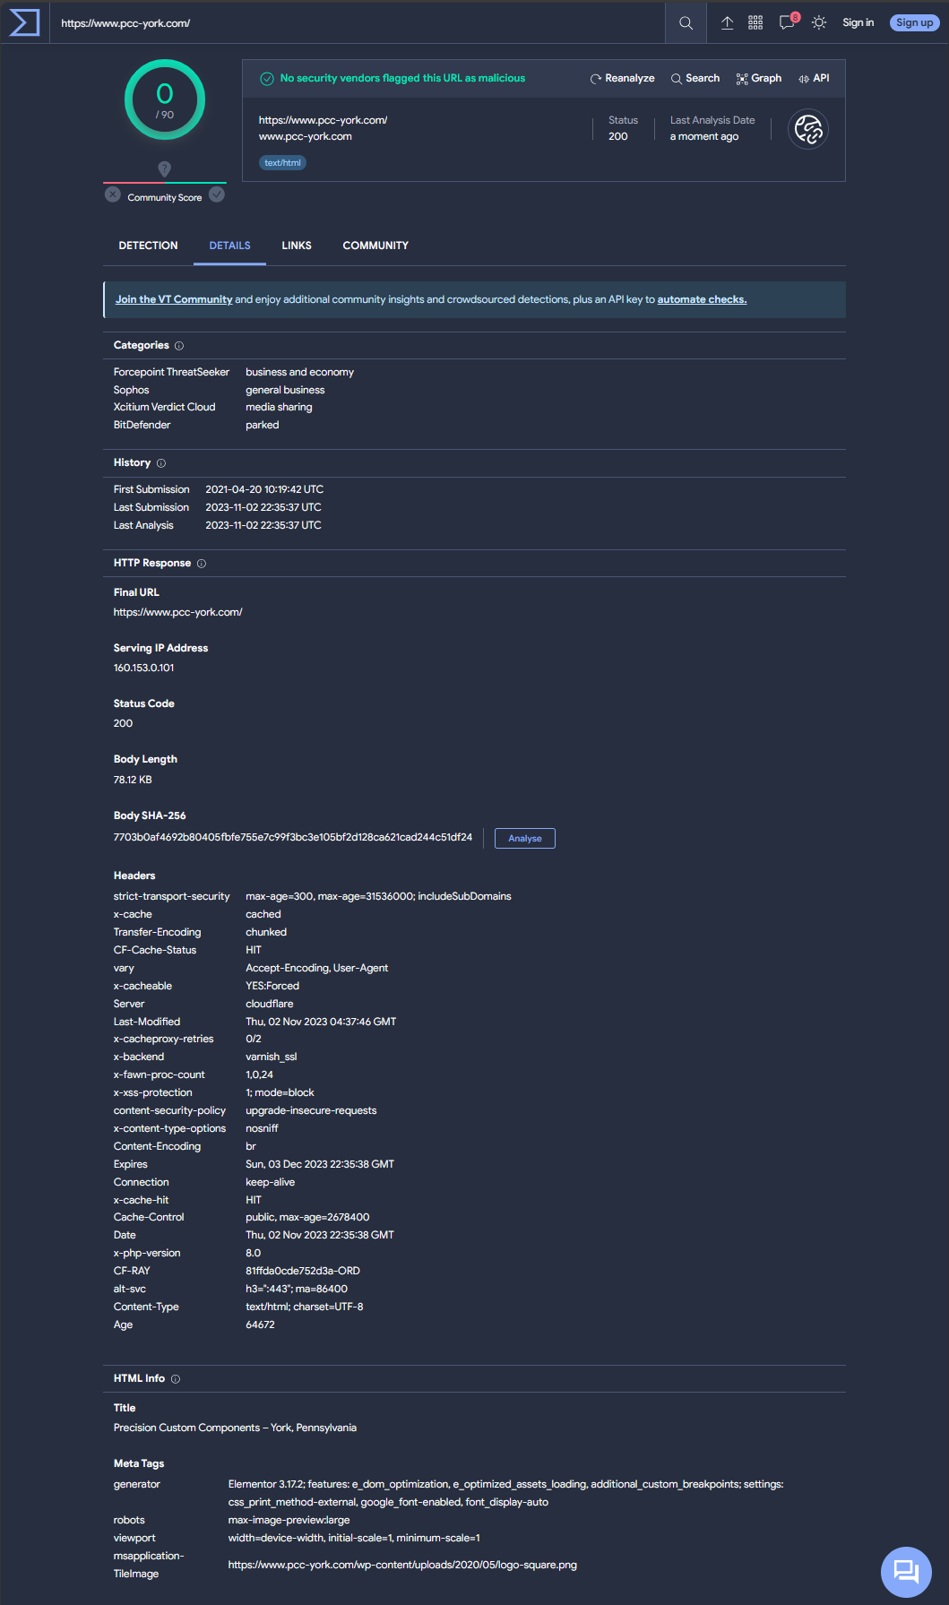

20. How could VirusTotal be useful to users? How could it be useful to security researchers? could it also be used by attackers to test their own malware before distributing it to ensure that it does not trigger an AV alert? What should be the protections against this?
A: VirusTotal can be used by users, researchers, attackers, and security professionals to test files and know what may or may not be protected in common AV systems around the globe. Attackers could benefit by knowing what may or may not be defended against and therefore have an edge against defense teams. A defense against this would be active monitoring and penetration testing.

